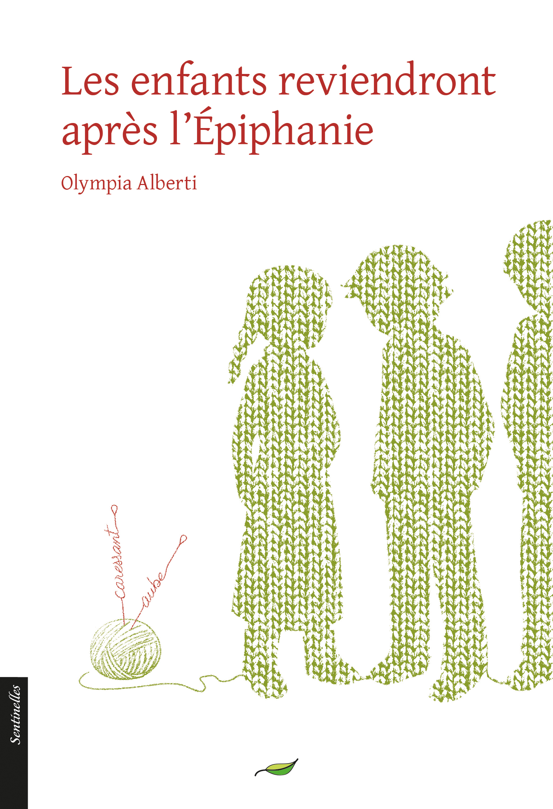
The children will return after epiphany

Genre(s):
- Novella
- Initiation story
- Historical fiction (18th century)

Keywords:
- Childhood
- First loves (LGBT)
- School and education
- The Enlightenment
- Nature (moutains)
- Prejudice

Audience: suitable for all audiences of all ages; fans of LGBT literature
Right sold abroad: /
Concept
The first childhood love between two young boys in the countryside during the Enlightenment. One of the first preschool teachers defends them against prejudice.
Universe and references
- Film Jane Eyre (Zeffirelli’s adaptation) and stories about nannies or governesses
- Pastor Oberlin and the men of the Enlightenment
- The invention of preschool
Pitch
March 1767 in the middle of nowhere in the Vosges Valley. Inspired by Pastor Oberlin, a young woman named Sara Banzet gathers together the toddlers and starts to teach them. As she teaches others, she also learns a few lessons herself and gradually invents what would become preschool.
But how do these little students react to what she is gently teaching them? And what exactly is going on between those two little boys, Nicko and Claude, who share such a passionate friendship?
Author
A doctor of literature in comparative literature, Olympia Alberti lives in Nice. Her work is known for its rigueur and depth and she has been the recipient of numerous awards (the French Academy’s poetry award, the “Prix des Créateurs” award, and the essay award from the “Société des gens de lettres.”)
At a glance
- Short story
- Word count: 53,000 characters including spaces
- Available material in English: this presentation (including an overview of the work’s characteristics) and a translated excerpt

Excerpt
The thirteenth of December.
There was a big celebration around the wood stove for the two newly returned friends. The children had decorated the stove with their drawings and bouquets of dried flowers. It was full of light, although the sky was gray with snow that had yet to fall.
They sang and read. Frédéric read his welcome poem and our little Jeanne read her sentence about friendship.
Each one of them had brought a little something for an afternoon snack fit for a king: a linzertorte made with bilberry jam, crepes, cream, and jam made of mirabelle plums and blackberries. Little Rachel and little Jean-Pierre were buzzing with excitement and little Micheline was as drunk as a wasp on all the sugar. Nicolette said, “This is better than Christmas, we’re all together!” Then she burst out into a laughing fit and we all laughed with her.
Little Nicko and little Claude stayed off to the side and didn’t leave one another. The children asked them thousands of questions. When I look at them, I feel all warm inside and my heart beats faster. I love having the quiet, gentle sound of their story in my life. As far as I can see, what they have is difficult and it’s a gift. Some people from around here, from Ban-de-la-Roche, Schirmeck, or Munster, have never experienced it and they never will. I believe that God only sends beautiful stories like theirs to the purest of hearts and too often, adults tarnish and ruin them with their filthy ideas.

The children will return after epiphany
Worldwide rights available

We would welcome the opportunity to discuss all offers regarding our rights.
Information regarding the acquisition of our rights: http://verger-editeur.fr/-Foreign-rights-
Complete catalog: http://www.verger-editeur.fr/-Catalogue-

